Articles, Nouns, Genitive Case, Conjunctions and Phrasal Verbs

Articles

Singular e Plural – THE

The smartphone I got is really awesome!
Did you buy the flowers I asked?

Antes de superlativo

He is the best one.
Vila Velha is the oldest city in Espírito Santo.
She is the most successful person in our office.

Unique Nouns

The rain.
The world
The sun.

Compose names of countries

The United States of America
The Netherlands
The Philippines

Not used the article THE

Countries

Italy is beautiful country
Brazil won the World Cup in 2002

Season of years

We have to go there in spring
My favorite season is summer

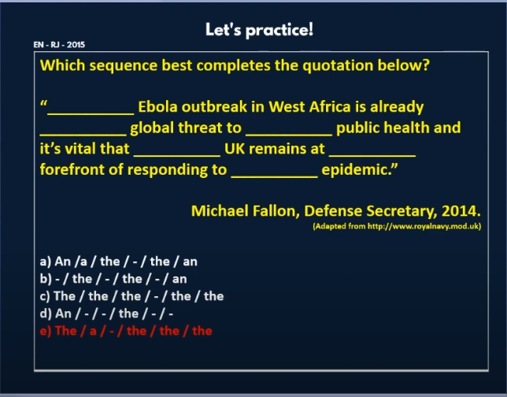
.

Notion

"Which" is a question word used to choose between options. It requires a noun or context to make sense.

❌ "Which you like?" → Missing verb
✅ "Which do you like?"

❌ "Which is your?" → Missing noun
✅ "Which is your favorite?"

1. Which
Used when choosing between known options.

"Which shirt looks better?" (Specific: you’re holding two shirts.)

"Which country uses the euro?" (Limited list of countries.)

2. What
Used for open-ended questions (no specific options).

"What’s your favorite color?" (Infinite possibilities.)

"What time is it?" (No limited choices.)

